**OakFest Open Air Market**

### Open Air Market Day

Part of our OakFest Week Long Celebration in July which includes an Open Air Market, Street Dance, Fishing Derby, Triathlon, Food Vendors, Parade, Paddle/Pedal/Road Race, Art Show & Live Music just to mention a few events...

Guidelines

**Downtown Oakland**

**“A Gateway to the Belgrade Lakes”**

### **A Great Small Town Maine Community**

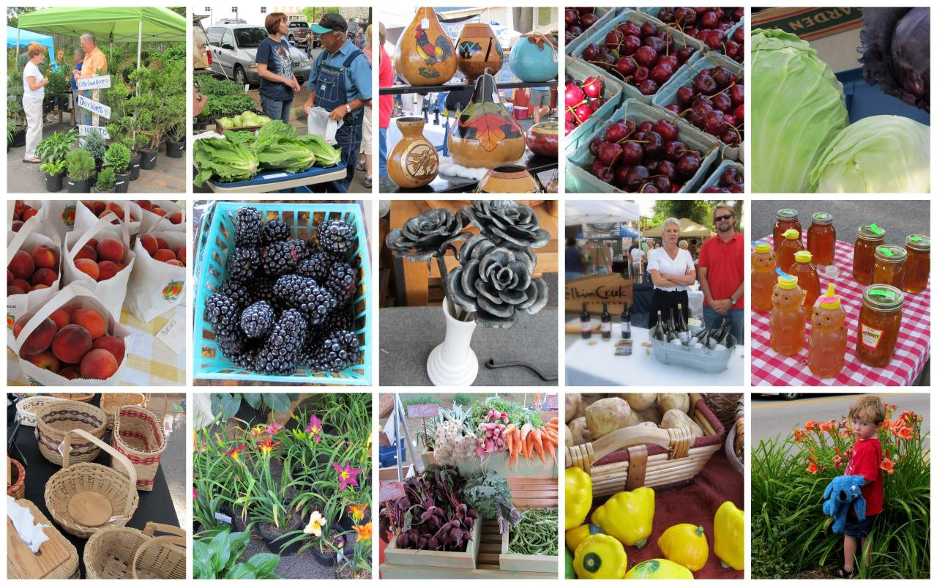

##### **Web:** [**www.OakFestMaine.com**](http://www.OakFestMaine.com) **Email:** [**OakFest@hotmail.com**](mailto:OakFest@hotmail.com)

### OakFest Open Air Market

The OakFest Open Air Market provides a comfortable location for consumers, farmers, and artisans to buy and sell “***fresh from the farm***” fruits, vegetables, plants, and “***handmade***” artisan products. This is not a flea market and we take great pride in limiting items for sale to those that help support and sustain the local and regional farm and artisan community.

Market staff and organizers will utilize many different advertising platforms for the promotion and advancement of the market, including but not limited to: social media, radio, banners, newspaper, press releases, and merchandise. These different platforms are prioritized by the Open Air Market Steering Committee and utilized when funding allows. Through sponsorships, the community and town officials have shown that they are committed to growing and cultivating the local food and artisan market while advancing Downtown Oakland as the heart of our community.

 Find us on Facebook @ OakFest Oakland Maine

### Open Air Market Guidelines

Welcome to the OakFest Open Air Market. To permit fair and equal opportunity for all sellers and to ensure quality products for buyers, the following guidelines have been developed. They will be revised and updated as needed. We want to work with you and welcome your ideas and suggestions at any time. To achieve maximum benefits and provide the best Market, everyone - vendors, customers, and management - must share and work together. Thank you for choosing the Oak Fest Open Air Market!

1. Market Manager

The Oakland Event Planning and Community Development Committee or his/her

designee serves as the Market Manager and as Steering Committee Chair. The Market Manager may deny the privilege of operating at the Market to any vendor who violates these guidelines and rules, or who otherwise takes actions which are determined by the Market Manager to be detrimental to the Market. The Market Manager specifically reserves the right to request additional information or documentation before making a decision to deny or limit access to the Market, but is not required by these guidelines to do so. The privilege of selling at the Market is not an entitlement. In utilizing his/her discretion to suspend, revoke, or otherwise terminate a seller’s privilege to sell on the Market, the Market Manager may consider a seller’s history of cooperation with Market management and the seller’s good faith effort to obey the guidelines and rules of the Market. The ultimate discretion for eligibility belongs to the Market Manager, and determinations are final once they are rendered.

2. Market Application

All vendors must submit a completed application along with the registration fee before they will be considered for the Market. The completed application must be submitted a minimum of 30 days before planning to vend, however, it is preferred that submissions be made by May 1st. Note: Location preference is given to early registrants. A Market vendor may be a grower as well as an artisan. A separate application is required for produce and artisan products.

Upon finding a non-compliant product, the vendor responsible for the product will be asked to immediately remove the product the first time and will be asked to leave the Market for the remainder of the season if it happens again. Items for sale may be added through ongoing approval of the Market Manager and amendment of vendor application.

1. Space Rental, Payment, and Fee Schedule

Each vendor will be responsible for providing their own tent, tables, chairs, and display

items as well as for the safety and security of their products. The Market does not accept responsibility for the loss or theft of any products. Market management will provide the vendor a space upon arriving at the market. Prior to site setup, the required fees must be paid. Payment may be made by cash or check to the Town of Oakland. All funds generated by the Market will be used for management, advertisement, and site accommodations. Payment is made with application to the event. All payments are final, **no refunds**. This is a rain or shine event. If a vendor requires a receipt for payment,(whether cash or check), he/she will be responsible for sending a self-addressed stamped envelope with the application.

Spaces cannot be transferred from one seller to another. All sellers who wish to claim a space must have product and be prepared to sell. Sellers are not to rent a space without product to sell, intending only to reserve the space. Each seller will be charged for all spaces being utilized, including display and storage spaces. Special exemptions can be approved by the Market Manager at his/her discretion. All items (e.g., tables, storage trailers, racks, boxes, refrigeration equipment, etc.) belonging to each seller on the Market must be kept within the rented space(s). If deemed appropriate, demonstration space will be provided by Market management at no cost. **Artisan craft demonstrations are highly encouraged within the market area**. All unapproved vehicles are subject to be towed at owner’s expense. The number and location of spaces available to vendors may be limited depending upon the type of products to be sold, variety of goods being sold, the season, and the type of event. **Vendor parking during market operation is to take place offsite**. **Special exemptions for produce/farm vendors can be approved by the Market Manager at his/her discretion.**

OPEN AIR MARKET FEE SCHEDULE

**Registration**

**Fee** ……….....…………………………………………………………………………**$45**

Late Registration Fee-After June 30th $ 55

Booth spaces are12' X 10'. Booth spaces are numbered If tents are used, they should be 10’x10’.

 Vendors cannot use any space beyond the 12’x10’ space (this includes music volume and the hawking of goods - everyone gets the same opportunity to sell their goods).

 All spaces must be clearly marked with name of vendor and products sold.

Example: Bath Heritage Museum - Heritage Crafts and Books

 All printed materials are subject to review by Market management and if

deemed inappropriate and/or misleading will be removed.

We accept cash and check. Credit and debit card payments can only be made at Oakland Town Office. If the vendor requires a receipt for his/her transaction, please visit Oakland Town Office for assistance. There is an extra fee for credit/debit cards.

Make Checks Payable to:

**Town of Oakland, OakFest Open Air Market** P.O. Box 187

Oakland, ME 04963

Attention: Kathy Paradis

1. **Hours of Operation**: Set up for vendors can begin at 7 AM (Please notify Manager is more time is required for setup). The Market operates on Saturday from 10 AM to 4 PM. **Break down and vacating of Market is not to occur until market closure**. Vendors with rented space may restock their product if necessary. When entering or exiting the Market site please practice safe vehicle operations to ensure public/ customer safety and comfort.

5.

**Garbage and Unsold Produce**: Garbage shall be disposed of in proper containers.

Unsold produce shall be carried home for disposal, donated to Food Programs, or offered to livestock feeders. Seller’s produce, plants, packaging or other trash shall not be placed in dumpsters or trashcans at the Market.

1. **Product Standards**: Sellers may not offer for sale any product that is unsound, unwholesome, or which fails to meet the requirements of federal, state, or local laws. **Sellers may sell only food or plant items and other items that are handmade and/or fresh from the farm.** Growers with perishable products such as fresh produce or plants may supplement the sale of these products with their farm type crafts or handmade products. Sellers are not to use a false pack - facing or topping of containers with the best products exposed and poor products underneath - or to knowingly pack products that are short in weight.

Craft and Artisan products, for the purpose of the OakFest Open Air Market, shall be determined to be: an item which an observer of the craft can appreciate the technique and execution of the employment of manual skill in the production of the product. All crafts must be hand crafted by the vendor or a member of the vendor's farm or craft unit.

Farm crafts are value added farm products produced predominately from materials grown or harvested by the crafts person or unit. Crafts must be the product of a home or cottage type industry using an intermediate type technology rather than an industrial type production. To be considered ‘handmade’, the item must show evidence of manual skills obtainable only through a significant period of experience and dedication.

The Market Manager has the discretion to immediately remove any product that he/she considers objectionable. If deemed necessary, the Town of Oakland Event Planning and Community Development Director and/or Open Air Market Steering Committee may review the decision within 30 days and make an official ruling on the matter.

1. **Baked Goods, Canned Items, Organic, and Pesticide Free**: In order for vendors to sell baked goods and canned items, sellers must label products and acquire approval (if [required) by the State of Maine](http://www.nchomeprocessing.com/). Only homemade baked goods may be sold. **State Approval is the responsibility of the vendor.** Sellers that plan to use the words “organically grown” or “pesticide free” must meet State of Maine Standards.
2. **Spraying and Pest Control**: Plants needing to be sprayed shall be returned to the farm for treatment. All live nursery stock (winter hard trees, shrubs, vines, perennial bulbs, turf grass, narcissus bulbs, strawberry plants, iris and daylily plants, rose plants, etc.) offered for sale must be apparently free of injurious plant pests and free of quarantined plant pests.

**Meat, Seafood, and Poultry**: In order to sell meats, fish, and poultry in the Market, vendors must adhere to all State of Maine Guidelines for selling meat, poultry and seafood and

1. then meet all State Requirements. **State Licenses and safety standards are the**

responsibility of the vendor.

1. **Contact Information Display**: All vendors must display their name, or farm name, and address on an appropriately sized sign; sellers must have at least one (1) sign and are

encouraged to provide adequate information for customers. Use of price cards is encouraged. A display height may not exceed 66” including product, beginning at the front of the space and going back 8 ft. **Sellers are responsible for accidents or injuries that occur within their rented space or involving their displays or equipment and may want to purchase a liability insurance policy**. Sellers may be asked to sign a statement about their use of and acceptance of responsibility for potentially dangerous items used in their spaces. Example: knives for cutting food

1. **Price Agreement Prohibition**: No user(s) of the Market shall enter into price agreements to raise, lower, or fix prices for products on the Market. Sellers are not to influence other sellers to sell lower or higher. Each vendor sells as they wish without interference.
2. **Electricity**: Televisions are not permitted. Check with Market Manager regarding any use

of electricity or generators. Salamander heaters will not be permitted.

1. **Offensive Behavior, Dogs, and Children**: Market users, sellers, or buyers are not to use profanity or abusive language, or verbally abuse other Market users, customers, and/or

Management. Dogs are prohibited.

Children must be supervised and not allowed to roam or interfere with other sellers or customers.

1. **Misc. Requirements**: Vehicles must be driven only by licensed drivers who observe the speed limit and posted signs. Cars must be moved from Point of Sale and left in designated parking areas. No person shall deface or damage the Market area. Gambling, the use of alcohol (except during special events), tobacco(not in vendor area), or other controlled substances is prohibited and persons under the influence of intoxicants or exhibiting disorderly conduct will be removed with the assistance of the Oakland Police Department. Sellers are not to possess firearms or fireworks in the Market. Users must keep their areas clean, sanitary, and orderly. Upon using provided restrooms, all produce and food vendors MUST wash hands before returning to booth. Honor boxes are not to be used. Notify the management if you discover product is missing and appears to have been stolen.
2. **Conflict Resolution**: If Market management finds that any of these rules are not being followed, the penalties will be:

1st Offense: 2nd Offense: 3rd Offense:

Verbal warning

Banned from all use of the Market for the day.

Banned from all use of the Market until meeting & resolving issues with Market Management for the following year.

1. **Customer Complaints**: It is the responsibility of the Market vendor(s) to satisfy customer complaints. Upon receipt of numerous complaints about the same vendor, this person/group may be denied privilege to use the Market. If anyone has a complaint about another vendor, be specific - write out information and give to Market Manager.

Please be good neighbors to our farmers and vendors as well as Market staff and adhere closely to each of these guidelines in order that we may continue to offer this program and provide an opportunity for you to sell.

WHILE THERE IS NO JURY, WE STRIVE FOR A BALANCED PRESENTATION OF GOODS.

The Market Manager may choose to limit the number of similar products offered and hence deny an application. If this occurs, acceptance will be awarded on a first come basis.

*Name:*

# Oakland, Maine

#### Farm Vendor Application

*Address:*

*Home Phone: Business/Cell Phone:*

*E-mail:*

Please mark all that apply (*offered for sale at Market*).

* Asparagus
* Apples
* Lima Beans
* Blueberries
* Snap Beans
* Peaches
* Beets
* Grapes
* Broccoli
* Pears
* Cabbage
* Strawberries
* Cantaloupe
* Pecans
* Collards
* Corn
* Cucumbers
* Eggplant
* Garden Peas
* Crafts: *list below*
* Other: *list below*

*Please list all other items to be sold:*

2. *_*

4. Use back of page if needed

*I have received, read, understood, and agree to abide by all Market rules, regulations, guidelines, and schedule of fees. I understand that my failure to follow the guidelines set forth will result in loss of selling privileges on the Market.*

Signature:

Date:

Registration Fee (**$**): $**45.00 by June 30th $55 after July 1st**. Date Paid and Management Signature:

Please return to:

OakFest Open Air Market

Town of Oakland Attention: Kathy Paradis email: [OakFest@hotmail.com](mailto:OakFest@hotmail.com)

Oakland, Maine 04963

207-465-7357| [www.OakFestMaine.com](http://www.oakfestmaine.com/)

***PAGE INTENTIONALLY LEFT BLANK***

Name:

#### Artisan,Crafters,Non-Profits,Artists,Health/Wellness,Business

Address:

Home Phone: Business/Cell (if available):

_

E-mail:

Please describe art/crafts proposed for sale and/or Description of Organization/Business:

* + - Use back of page if needed

###### Note: For Art & Artisan Products-Please include 2 pictures -Other categories do not need pictures

If demonstration space will be needed, please give details on demonstration that is proposed (use separate page if needed):

*I have received, read, understood, and agree to abide by all Market rules, regulations, guidelines, and schedule of fees. I understand that my failure to follow the guidelines set forth will result in loss of selling privileges on the Market.*

Signature:

Date:

*\*Please notify Market management if there is a change in contact information and/or products offered for sale.*

Before 7/1 Registration Fee ($): **45.00**

After 7/1 Fee $55.00

Date Paid and Management Signature:

Please return to:

OakFest Open Air Market

Town of Oakland Attention-Kathy Paradis

P.O. Box 187

Oakland, Maine 04963

207-465-7357 [www.OakFestMaine.com](http://www.oakfestmaine.com/)

email: [OakFest@hotmail.com](mailto:OakFest@hotmail.com)

## PAGE INTENTIONALLY LEFT BLANK

*Open Air Market Guidelines*